User Interface Documentation
Version: | 0.2
Editors: | GH
Created: | 28.03.2009

Version | Date | Author(s) | Changes
0.1 | 03/28/2009 | GH | Initial version
0.2 | 04/01/2009 | GH | Added all images & descrptions
Contents
1. Introduction 3
2. User Interface 3
2.1. General Layout 3
2.1.1. DecidR Logo 3
2.1.2. Horizontal Navigation Bar 3
2.1.3. Vertical Navigation Bar 4
2.1.4. Content 4
2.2. Register - Selection 6
2.3. Register – Tenant 7
2.4. Register - User 8
2.5. Password Lost 9
2.6. Profile Page 10
2.7. Change E-Mail 11
2.8. Change Password 12
2.9. Leave Tenant 13
2.10. Work Items 14
2.11. Change Tenant 15
2.12. Create Workflow Instance 16
2.13. Show Workflow Instances 17
2.14. Show Workflow Instance Items 18
2.15. Workflow Instance Configuration 19
2.16. Workflow Instance Configuration – Add User 20
2.17. Create Workflow Model 21
2.18. Import Workflow Model 22
2.19. Appoint Workflow Admin 23
2.20. Tenant Settings 24
2.21. Advanced Tenant Settings 25
2.22. Edit User List 26
2.23. Approve Tenant 27
2.24. Approved Tenants 28
2.25. Show User List 29
2.26. System Settings 30
2.27. Template Pages 31
2.27.1. Invitation 31
2.27.2. Confirmation 32

Introduction

This document is an appendix to the document "Software Requirements Specification for DecidR", herein after referred to as [spec].

User Interface

General Layout

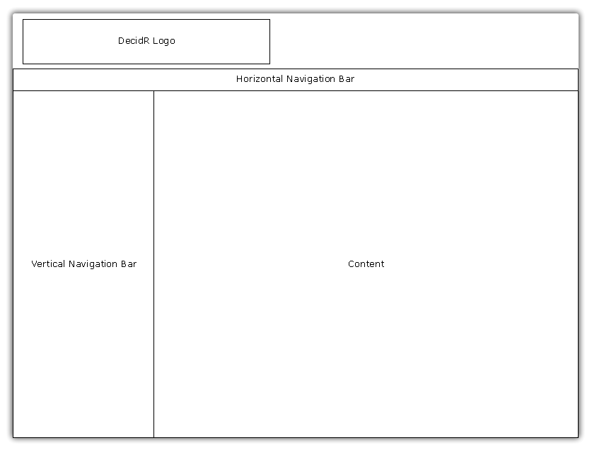
Figure 1: general layout of the website

The general layout of the website consist of the "DecidR Logo", a "Horizontal Navigation Bar", a "Vertical Navigation Bar" and a "Content" plane.

DecidR Logo
The logo of DecidR. It will be displayed on every website based on the layout of Figure 1.

Horizontal Navigation Bar
The horizontal navigation bar always displays the following four links, allowing navigation to the specified websites:
- Home
Links to: Public Welcome Page / Tenant Welcome Page. Which page is linked depends on whether the user is logged in and is member of a tenant or not and/or followed a link to a tenant welcome page.
Referred Use Case:
- Help
Links to: Help
- Terms of Service
Links to: Terms of Service
- Impressum
Links to: Impressum

Vertical Navigation Bar
The content of the vertical navigation bar varies, depending on login state and user rights at the selected tenant:
- not logged in
Displays two input fields (username, password)
Links to: Password Lost, see 2.5
Links to: Register - Selection, see 2.2
- logged in: user
Links to: Work Items, see 2.10
Links to: Change Tenant, see 2.11
Links to: Profile Settings, see 2.6
- logged in: workflow admin
All links from logged in: user in addition to the following:
Links to: Create Workflow Instance, see 2.12
Links to: Show Workflow Instances, see 2.13
- logged in: tenant admin
All links from logged in: workflow admin in addition to the following:
Links to: Workflow Models, see 2.17
Links to: Tenant Settings, see 2.20
Links to: Edit User List, see 2.22
- logged in: super admin
Links to: Approve Tenant, see 2.23
Links to: Approved Tenants, see 2.24
Links to: System Settings, see 2.26
Links to: Show User List, see 2.25

Content
The content plane displays the content of each page and will be described in the following. Please note that the following pages are not described, since they only contain static text and/or do not offer links or possible user actions:
- Public Welcome Page
- Tenant Welcome Page
- Help
- Terms of Service
- Impressum
- Any page that informs the user about the success of a previous action

The following images contain black lines as visual helpers, to determine the size of the original content plane.

Register - Selection
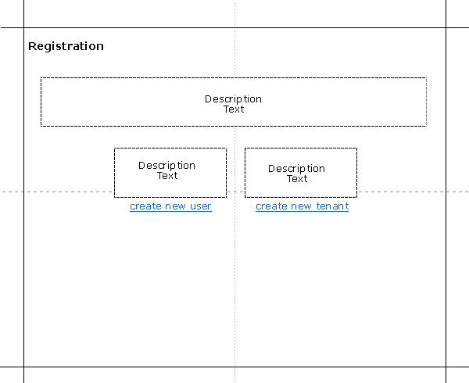
Figure 2: registration selection

Referred Use Case: [spec] 6.2.1, 6.2.2
Links to: Register – Tenant, see 2.3
Register – User, see 2.4

Register – Tenant
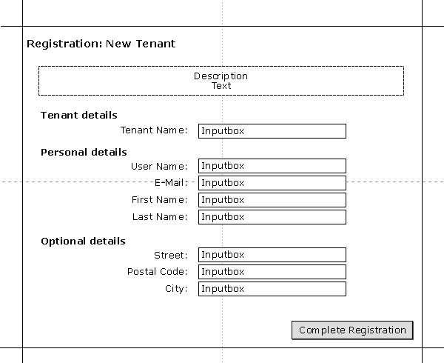
Figure 3: register tenant

Referred Use Case: [spec] 6.2.1
Links to:

Register - User
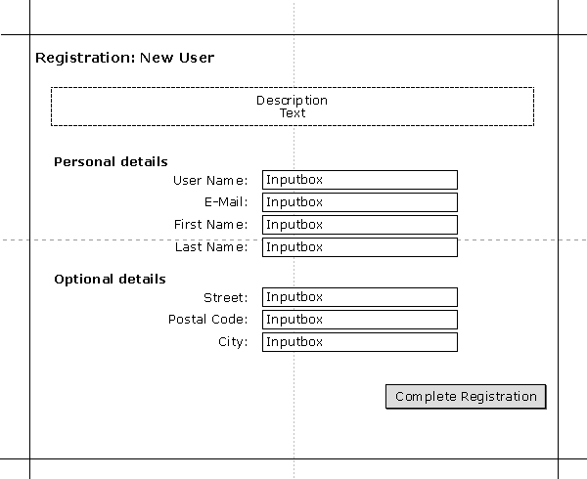
Figure 4: register user

Referred Use Case: [spec] 6.2.2
Links to:

Password Lost
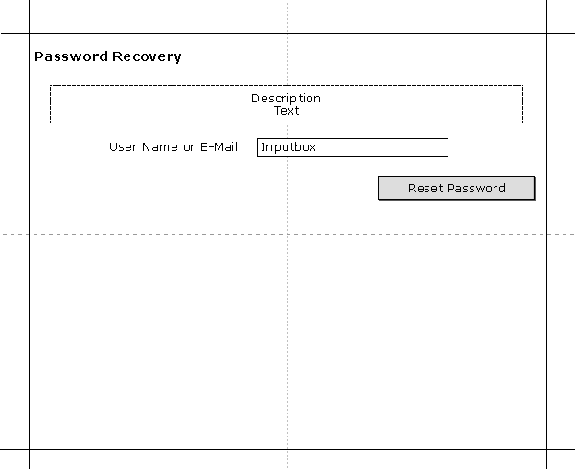
Figure 5: password lost

Referred Use Case: [spec] 6.2.6
Links to:

Profile Page
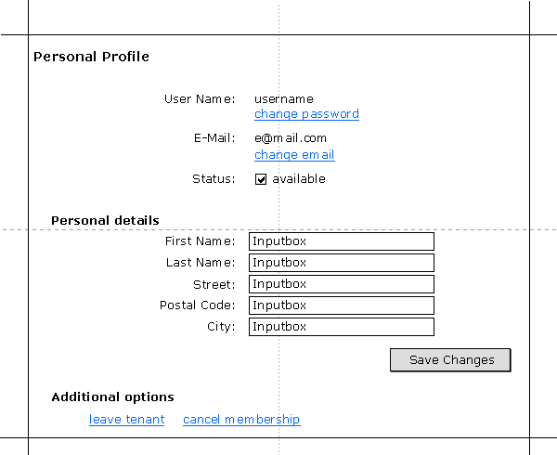
Figure 6: profile page

Referred Use Case: [spec] 6.2.9, 6.2.10, 6.2.11, 6.2.12, 6.2.16, 6.2.17, 6.2.18
Links to: Change Password, see 2.8
Change E-Mail, see 2.7
Leave Tenant, see 2.9
Cancel Membership, see 2.27.2

Change E-Mail
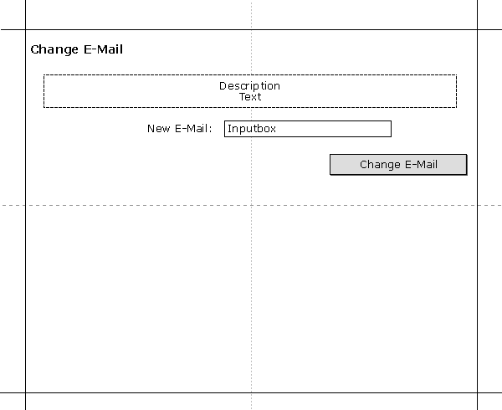
Figure 7: change email

Referred Use Case: [spec] 6.2.9
Links to:

Change Password
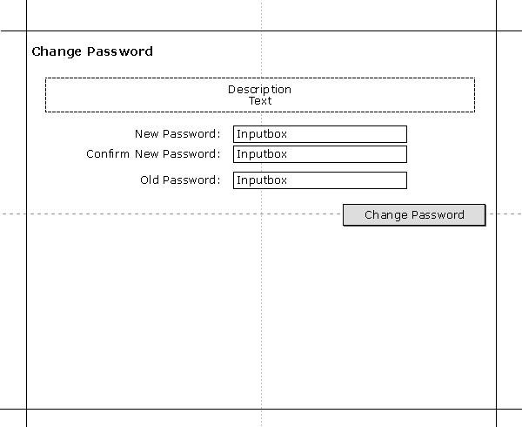
Figure 8: change password

Referred Use Case: [spec] 6.2.10
Links to:

Leave Tenant
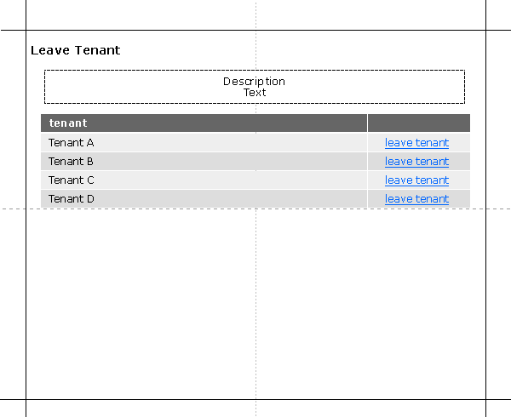
Figure 9: leave tenant

Referred Use Case: [spec] 6.2.18
Links to:

Work Items
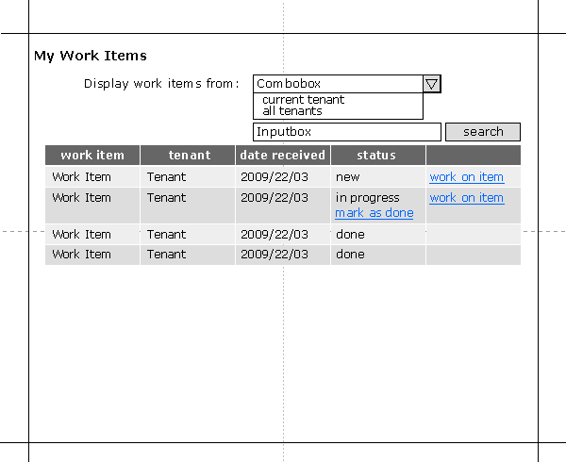
Figure 10: work items

Referred Use Case: [spec] 6.3.1
Links to:

Change Tenant
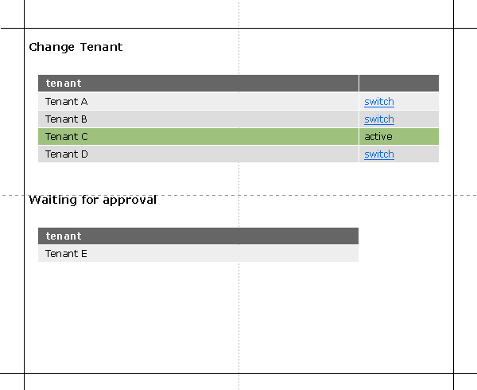
Figure 11: change tenant

Referred Use Case: [spec] 6.2.15
Links to:

Create Workflow Instance
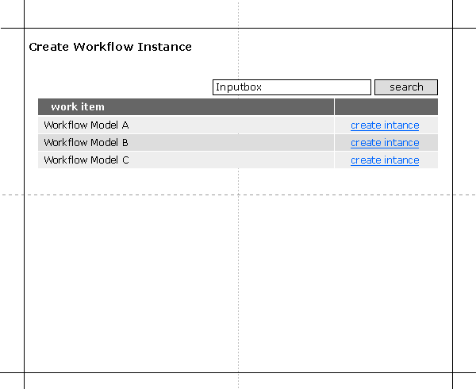
Figure 12: create workflow instance

Referred Use Case: [spec] 6.4.1
Links to:

Show Workflow Instances
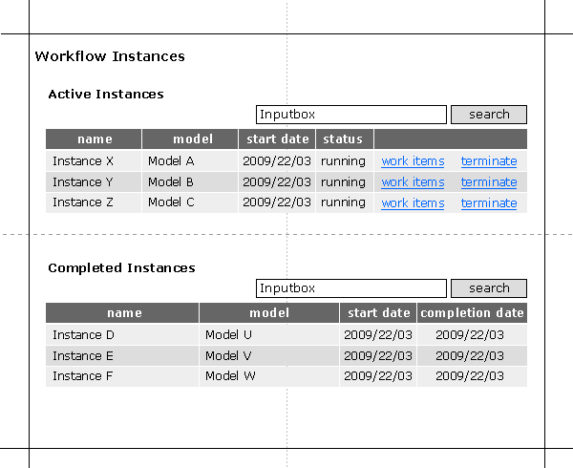
Figure 13: show workflow instances

Referred Use Case: [spec] 6.4.2
Links to: Show Workflow Instance Items, see 2.14

Show Workflow Instance Items
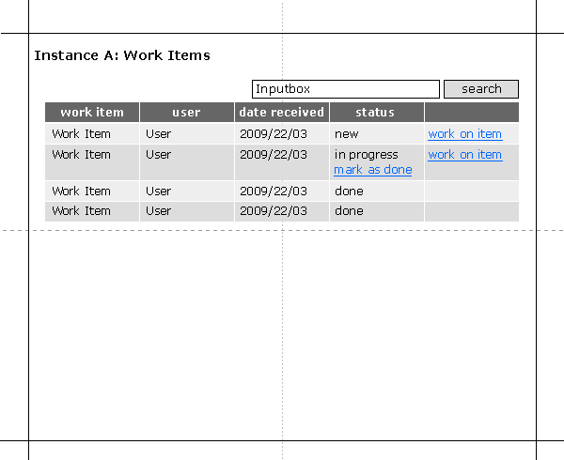
Figure 14: show workflow instance items

Referred Use Case: [spec] 6.4.9
Links to:

Workflow Instance Configuration
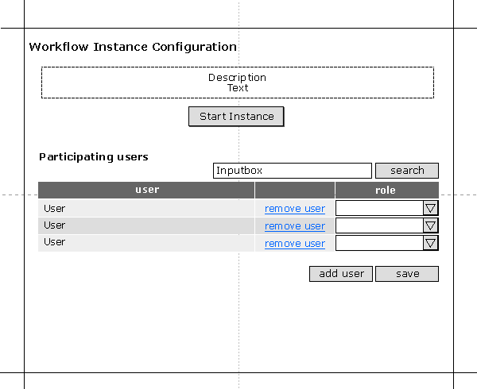
Figure 15: workflow instance configuration

Referred Use Case: [spec] 6.4.4
Links to:

Workflow Instance Configuration – Add User
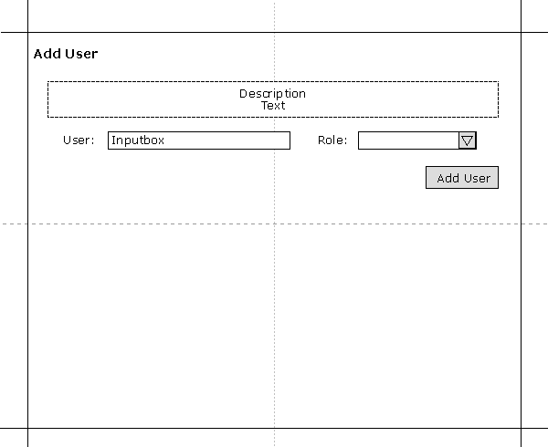
Figure 16: workflow instance configuration - add user

Referred Use Case: [spec] 6.4.7
Links to:

Create Workflow Model
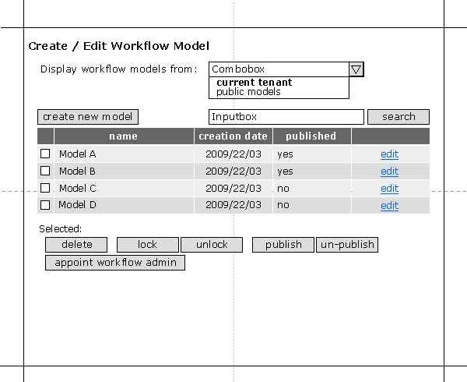
Figure 17: create workflow model

Referred Use Case: [spec] 6.7.1, 6.7.2, 6.7.3, 6.7.4, 6.7.6, 6.7.7, 6.7.8, 6.7.10
Links to: Import Workflow Mode, see 2.18

Import Workflow Model
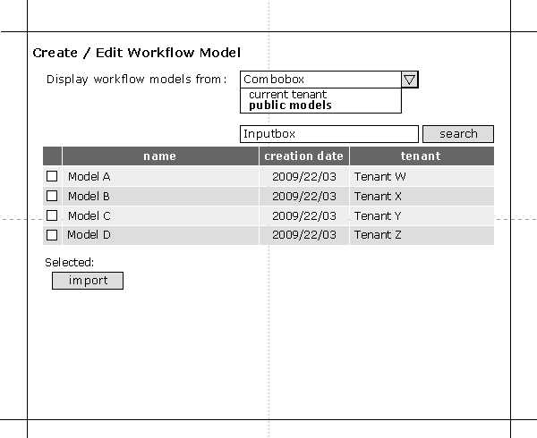
Figure 18: import workflow model

Referred Use Case: [spec] 6.7.8
Links to: Create Workflow Model, see 2.17

Appoint Workflow Admin
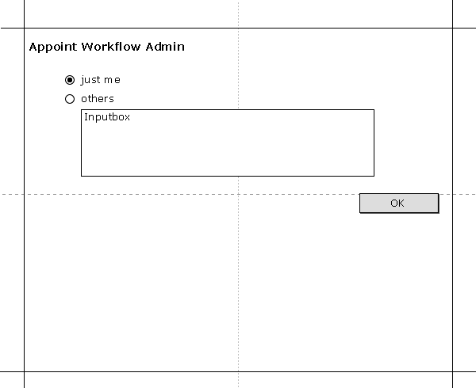
Figure 19: appoint workflow admin

Referred Use Case: [spec] 6.7.10, 6.7.10.1, 6.7.10.2, 6.7.10.3
Links to:

Tenant Settings
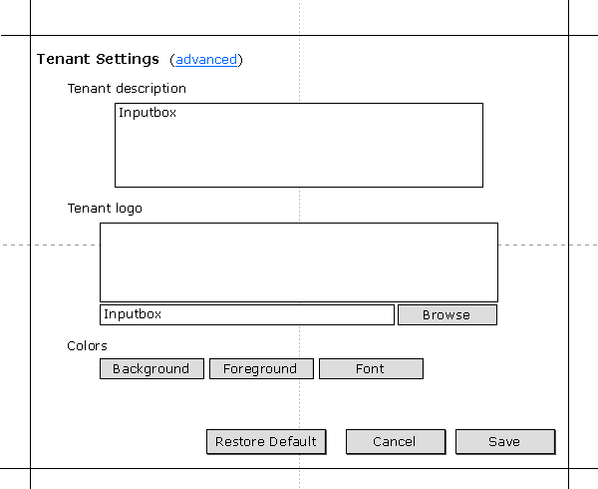
Figure 20: tenant settings

Referred Use Case: [spec] 6.5.1, 6.5.1.1, 6.5.1.3, 6.5.2
Links to: Advanced Tenant Settings, see 2.21

Advanced Tenant Settings
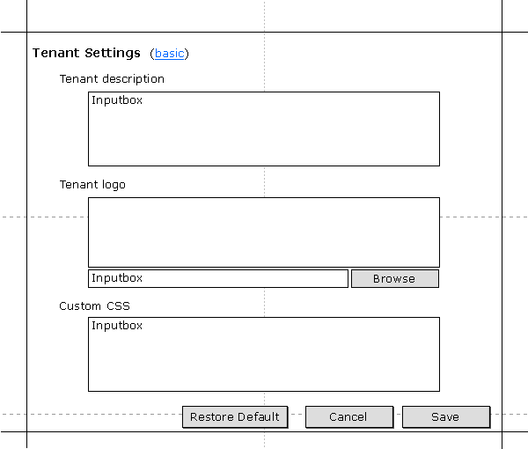
Figure 21: advanced tenant settings

Referred Use Case: [spec] 6.5.1, 6.5.1.1, 6.5.1.2, 6.5.2
Links to: Tenant Settings, see 2.20

Edit User List
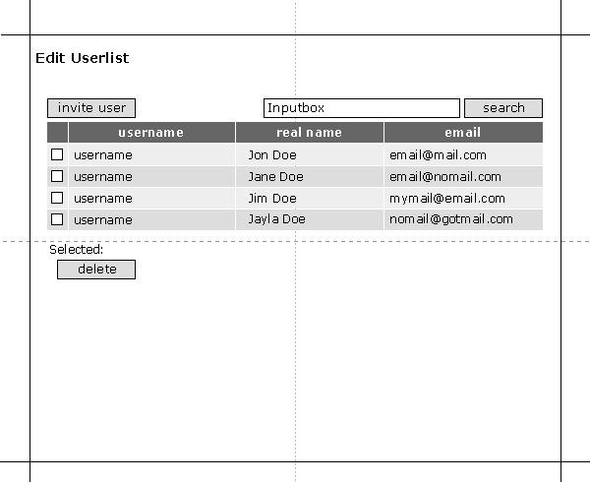
Figure 22: edit user list

Referred Use Case: [spec] 6.6.2, 6.6.3
Links to:

Approve Tenant
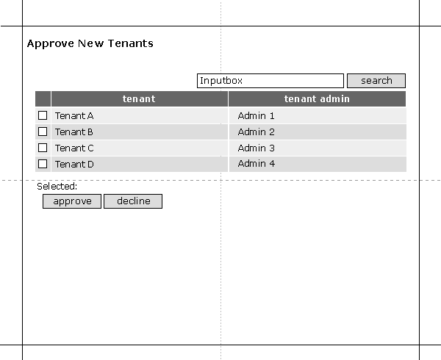
Figure 23: approve tenant

Referred Use Case: [spec] 6.13.3
Links to:

Approved Tenants
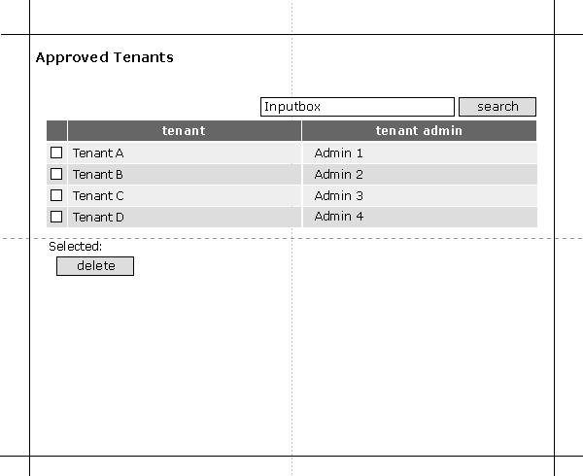
Figure 24: approved tenants

Referred Use Case: [spec] 6.13.1
Links to:

Show User List
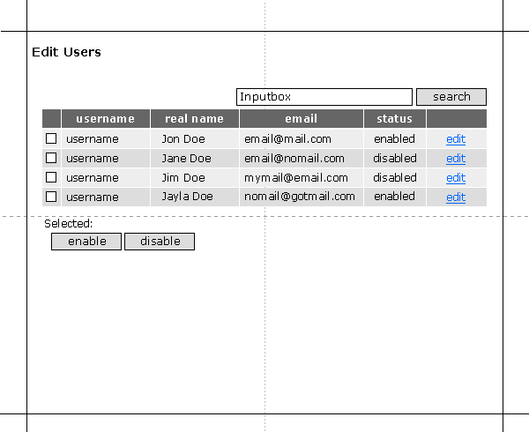
Figure 25: show user list

Referred Use Case: [spec] 6.12.1, 6.12.2, 6.12.3
Links to:

System Settings
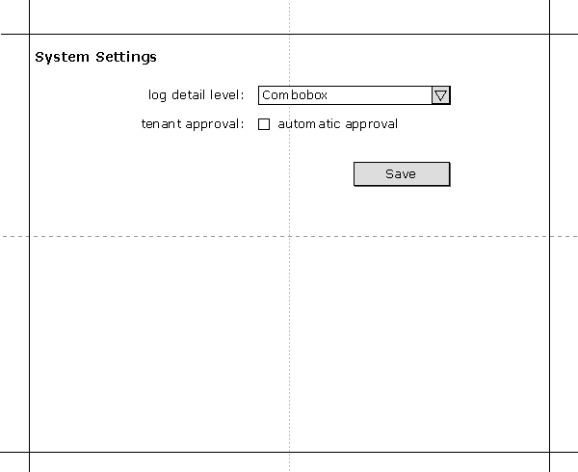
Figure 26: system settings

Referred Use Case: [spec] 6.10.1
Links to:

Template Pages
These pages might be reused in different contexts with different description texts.

Invitation
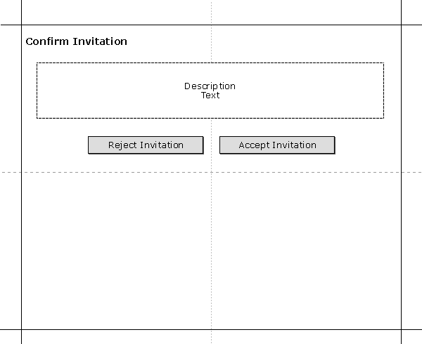
Figure 27: invitation

Referred Use Case: [spec] 6.2.7, 6.2.8
Links to:

Confirmation
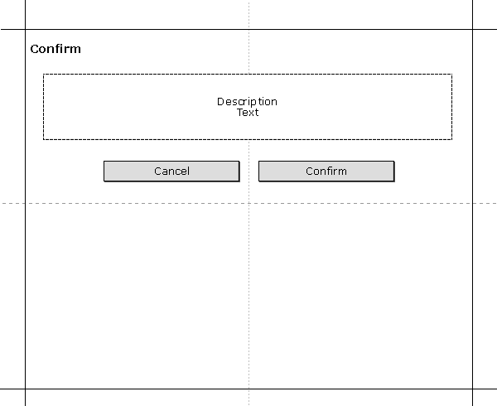
Figure 28: confirmation

Referred Use Case: [spec] 6.2.12, 6.2.18
Links to:

